QuadraticEquation Mastery Assignment
Reflection Log
Stefan S
CSE 2140 2nd Language Programming
(QuadraticEquation.java)
How has your program changed from planning to coding to now? Explain.
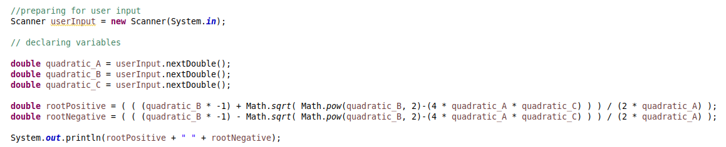
This is the first working version of the program. It doesn’t deviate from the plan made on the IPO chart. I am honestly surprised that I didn’t make any errors in regards to order of operations. I verified my results by googling for a quadratic equation with simple roots and plugging it in: (1x^2) – (3x) – (4)
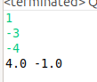

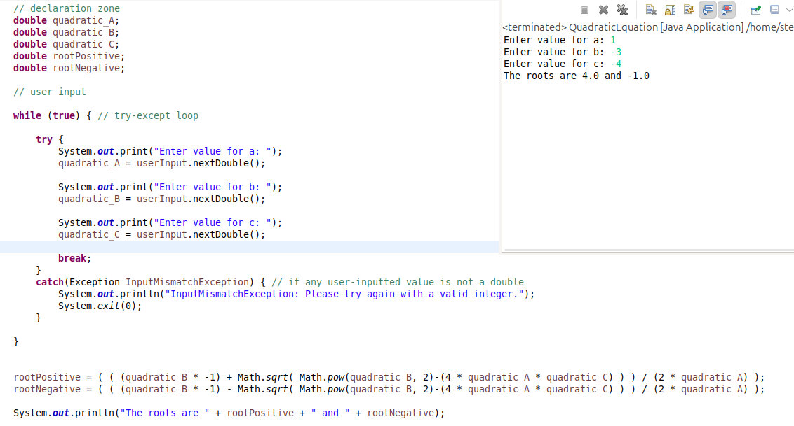
Final program is the same, with text added and a try-except loop to catch errors.

